Utah Division of Wildlife Resources Fishery Monitoring Report

**Author**: Taylor R. Stewart  
**Contact**: [taylorstewart@utah.gov](mailto:taylorstewart@utah.gov)

**System**: Causey Reservoir  
**Sampling Dates**: 6/6/2023 - 6/13/2023  
**Target Species**: Brown Trout, Cutthroat Trout, Kokanee, Rainbow Trout, and Tiger Trout  
**Species Stocked**: Rainbow Trout, Cutthroat Trout, Lake Trout, and Tiger Trout

**Monitoring Objectives**:

1. Provide data for assessment of trends in species occurrence, relative abundance, biomass, and size structure of forage and sport fish assemblages.
2. Evaluate population indices to improve the effectiveness of stocking efforts.

**Sampling Design and Methods**:  
*Curtain Nets*  
A new sampling design was implemented in 2023 to improve the effectiveness of sampling methods in reservoirs that contain Kokanee and in deep reservoirs where benthic gillnets do not effectively quantify species that occupy pelagic habitats. The sampling design used experimental gillnets with extended depths (*i.e.,* curtain gillnets) suspended in the water column, thus giving managers the ability to sample benthic and pelagic habitats simultaneously or sample stratified portions of the pelagic fish community. Sampling occurred in the spring. Three curtain gillnets were suspended in the pelagic zone at 6-m depth intervals ranging from 0 to 18-m depth and an additional curtain gillnet was set nearshore with 6 m of water to sample the benthic and littoral habitats (Table 1). All curtain nets were 45.7 m long by 6.1 m deep with six 7.6-m panels that had bar mesh sizes of 13, 19, 25, 38, 51, and 64 mm. Nets were set overnight and retrieved at dawn. This sampling design was replicated at two sampling sites in distinct regions of the reservoir (Figure 1). All fish caught were measured for total length (mm) and weight (g).

Prior to 2023, experimental benthic gillnets were used to conduct sampling. Benthic gillnets were 24.8 m long by 1.8 m deep with eight 3.1-m panels that had bar mesh sizes of 19, 25, 32, 38, 44, 51, 57, and 64 mm. The change in gear types precludes our ability to analyze catch rate and biomass data prior to 2023 as the assumption that catchability was constant between gear types is violated.

*Statistical Methods*  
All fish caught were identified to species and measured for total length (mm) and weight (g). Benthic gillnet and curtain gillnet data were combined to increase the sample size and statistical inference of size structure analyses. Relative abundance (*i.e.,* catch-per-unit-effort) and biomass were analyzed as the respective number or weight for each species per net-night. Size structure was presented as an empirical cumulative distribution function (ECDF) and a histogram. The ECDF, which is the proportion of fish that are less than each observed length, was used to analyze changes among years while the histogram was used to show the frequency of individuals in each length interval for a single year. Weight-length residuals and relative weight were used as condition metrics.

**Summary**:  
*Species Composition*  
Fish catches were comprised of Brown Trout, Cutthroat Trout, Kokanee, Rainbow Trout, Redside Shiner, *Cottus* spp., and Tiger Trout (Figure 2). No Lake Trout were observed. Kokanee were the most abundant species by number caught (67.9%) and weight (46.7%) in curtain nets. Redside Shiner was 17.3% of the catch and was an abundant forage species observed (Figure 2).

*Abundance*  
Kokanee mean relative abundance was 29.9 fish/net-night (SE = 9.2), and had the highest relative abundance in the 0 to 6-m depth zones (Figures 3 & 4). The catch rate of Kokanee at Causey Reservoir was significantly higher than other Kokanee fisheries in the region and likely contributed to the changes in sampling methods. Rainbow Trout mean relative abundance was 9.0 fish/net-night (SE = 2.9) and had low catch rates in the quality-length or greater categories (Figure 5). Brown Trout, Cutthroat Trout, and Tiger Trout were all found in low densities (mean relative abundance < 2 fish/net-night) but were all present in preferred-length or grater categories (Figures 3 & 5). The lack of historical data prevents knowing normal bounds and trends for these analyses.

*Biomass*  
Kokanee and Rainbow Trout were the dominant species by biomass (mean relative biomass = 4.5 & 4.2 kg/net-night, respectively; Figure 6). The mean relative biomass of Brown Trout, Cutthroat Trout, and Rainbow Trout were below 1.5 kg/net-night (SE < 0.8; Figure 6). The lack of historical data prevents knowing normal bounds and trends for these analyses.

*Size Structure*  
The size structure of Kokanee shifted to smaller individuals from previous sampling and low numbers of individuals (< 10) were observed in the preferred-length or larger categories (Figures 7 & 8). Historical sampling efforts highlight a cyclic pattern of density dependency with Kokanee in the system and could be an explanation for the shift in size structure. Rainbow Trout size structure improved but this was likely a relic of the recent increase in length-at-stocking. The size structure of Brown Trout, Cutthroat Trout, and Tiger Trout largely remained the same or had low sample sizes to be confident in the results. Shifts in length distributions between 2016 and 2023 were statistically different, based on a bootstrapped Kolmogorov-Smirnov test, for Kokanee (*P* = 0.003) and Rainbow Trout (*P* < 0.001; Figure 7).

*Condition*  
Relative weights of Kokanee and Rainbow Trout were low and variable but had a positive relationship with total length (Figure 10). Brown Trout and Tiger Trout were low and had a negative relationship with total length. Cutthroat Trout relative weight remained stable but low number of observations limited confidence (Figure 10).

*Stocking*  
Stocking quotas are largely being met and maintained (Figure 11). Excess Cutthroat Trout broodstock were stocked during the summer and was a one-time stocking event.

All other measurements and indices appear within normal bounds.

**Management Actions**:

1. Continue to perform the new sampling design with curtain gillnets. After an additional two years of data collection, a power analysis will be conducted to determine the effectiveness of the new sampling design. Sampling effort may need to increase to provide accurate and reliable population estimates. The lack of trend data limits making informed management actions.
2. Continue monitoring the Kokanee population. The inlet river was monitored in 2023 to quantify the intensity of the Kokanee spawn. Total length and opercles were collected from spent adults to identify the age-class(es) spawning. Current recommendation is to perform additional years of monitoring during the spawn to establish a baseline across multiple years as Kokanee are highly sensitive to environmental conditions and anthropogenic effects.
3. The Kokanee spawn at Causey Reservoir has become a major tourist attraction with upwards of 2,000 people visiting per weekend day. Current recommendation is to coordinate with the U.S. Forest Service to deter the public from negatively impacting the spawn while ensuring viewing opportunities persist (*e.g.,* displaying additional signs, possibly having trained personnel on-the-ground to educate the public on laws, etc.).

**Tables:**

Table 1: Date of collection, number of samples collected by sampling gear type, prescribed number samples by sampling gear type, mean water temperature (°C), and any additional data collected from Causey Reservoir in 2023.

| Gear Type | Date | # of Samples | # of Prescribed Samples | Water Temperature | Additional Comments |
| --- | --- | --- | --- | --- | --- |
| Curtain Gillnets | 6/6/2023 - 6/13/2023 | 8 | 8 | 11.7 | – |

Table 2: Mean total length (TL; mm), mean weight (WT; g), mean relative weight (Wr), and percentage of individuals within each traditional proportional size distribution (PSD) category for each target species from Causey Reservoir in 2023. All values in parentheses indicate standard deviation.

| Target Species | Mean TL | Mean WT | Mean Wr | PSD-  Quality | PSD-  Preferred | PSD-  Memorable | PSD-  Trophy |
| --- | --- | --- | --- | --- | --- | --- | --- |
| Brown Trout | 401.3  (163.5) | 936.7  (787.8) | 91.7  (21.5) | 75 | 75 | 25 | 12 |
| Cutthroat Trout | 424.2  (105.4) | 971.0  (762.0) | 99.3  (9.0) | 60 | 40 | 0 | 0 |
| Kokanee | 225.3  (57.2) | 161.0  (366.0) | 76.4  (13.9) | 50 | 3 | 0 | 0 |
| Rainbow Trout | 348.3  (47.6) | 471.4  (344.0) | 86.9  (9.5) | 6 | 2 | 0 | 0 |
| Tiger Trout | 414.0  (87.4) | 660.7  (388.7) | 71.2  (8.1) | 100 | 67 | 0 | 0 |

**Figures:**

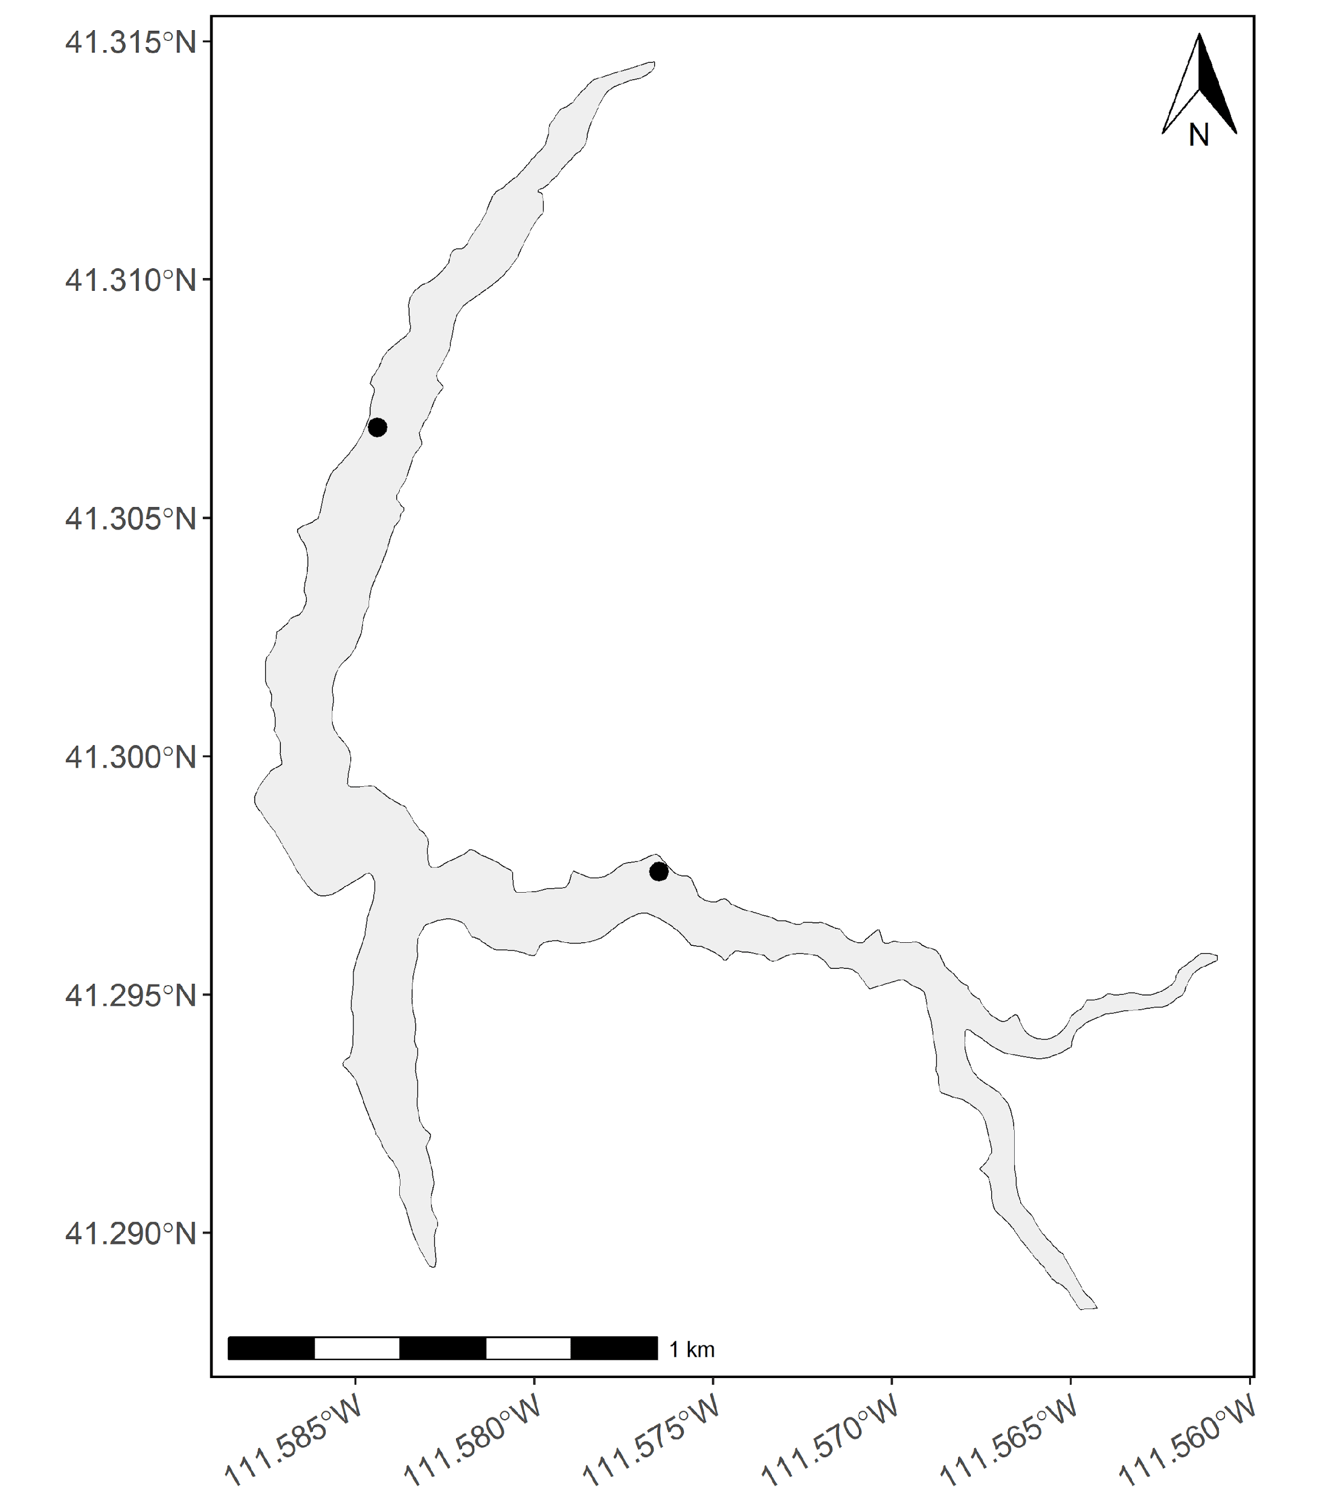

Figure 1: Map of Causey Reservoir sampling sites. Curtain net sampling locations are denoted as black circles.

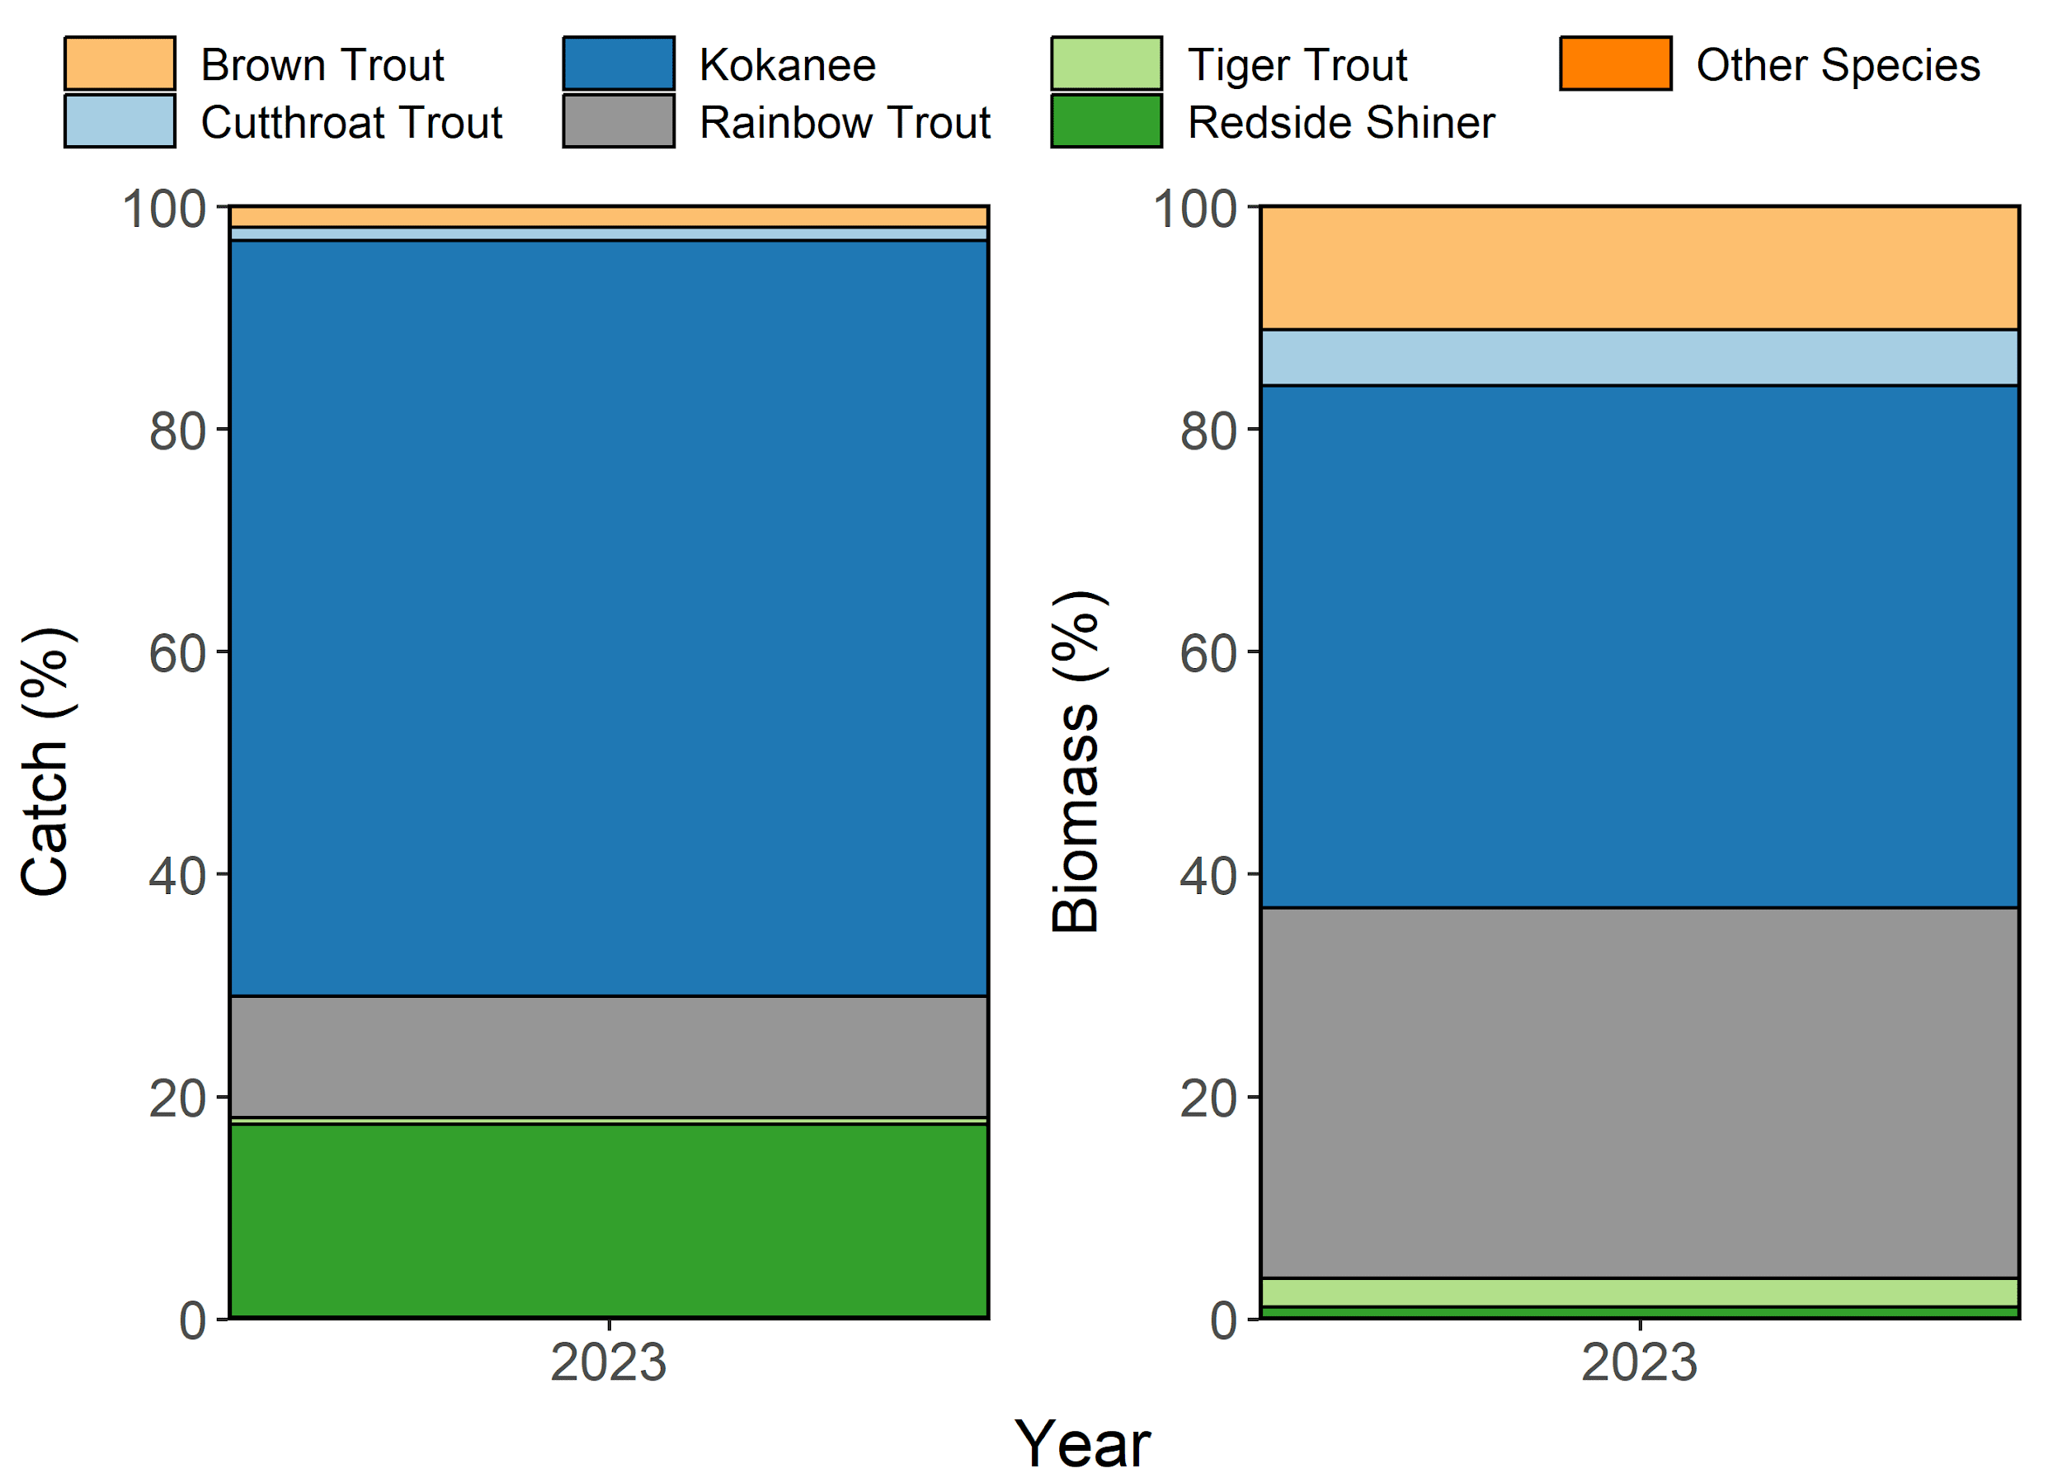

Figure 2: Species composition (%) by catch (# of fish) and biomass (kg) of Brown Trout, Cutthroat Trout, Kokanee, Rainbow Trout, and Tiger Trout sampled in curtain nets from Causey Reservoir in 2023. Other species include Cottidae spp..

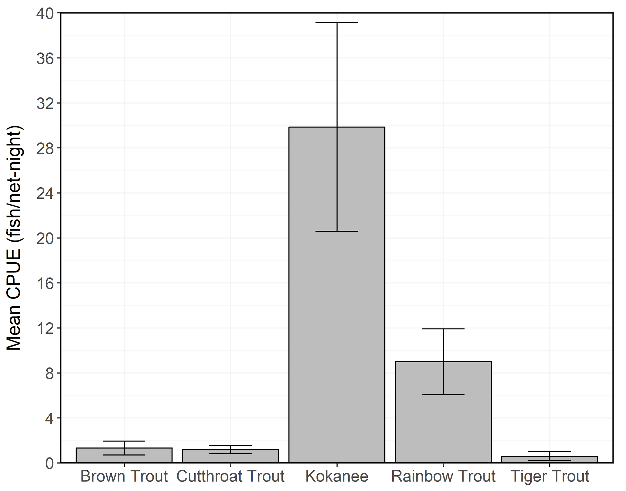

Figure 3: Mean relative abundance (CPUE; fish/net-night) of stock-length Brown Trout, Cutthroat Trout, Kokanee, Rainbow Trout, and Tiger Trout sampled in curtain nets from Causey Reservoir in 2023. Error bars indicate standard error.

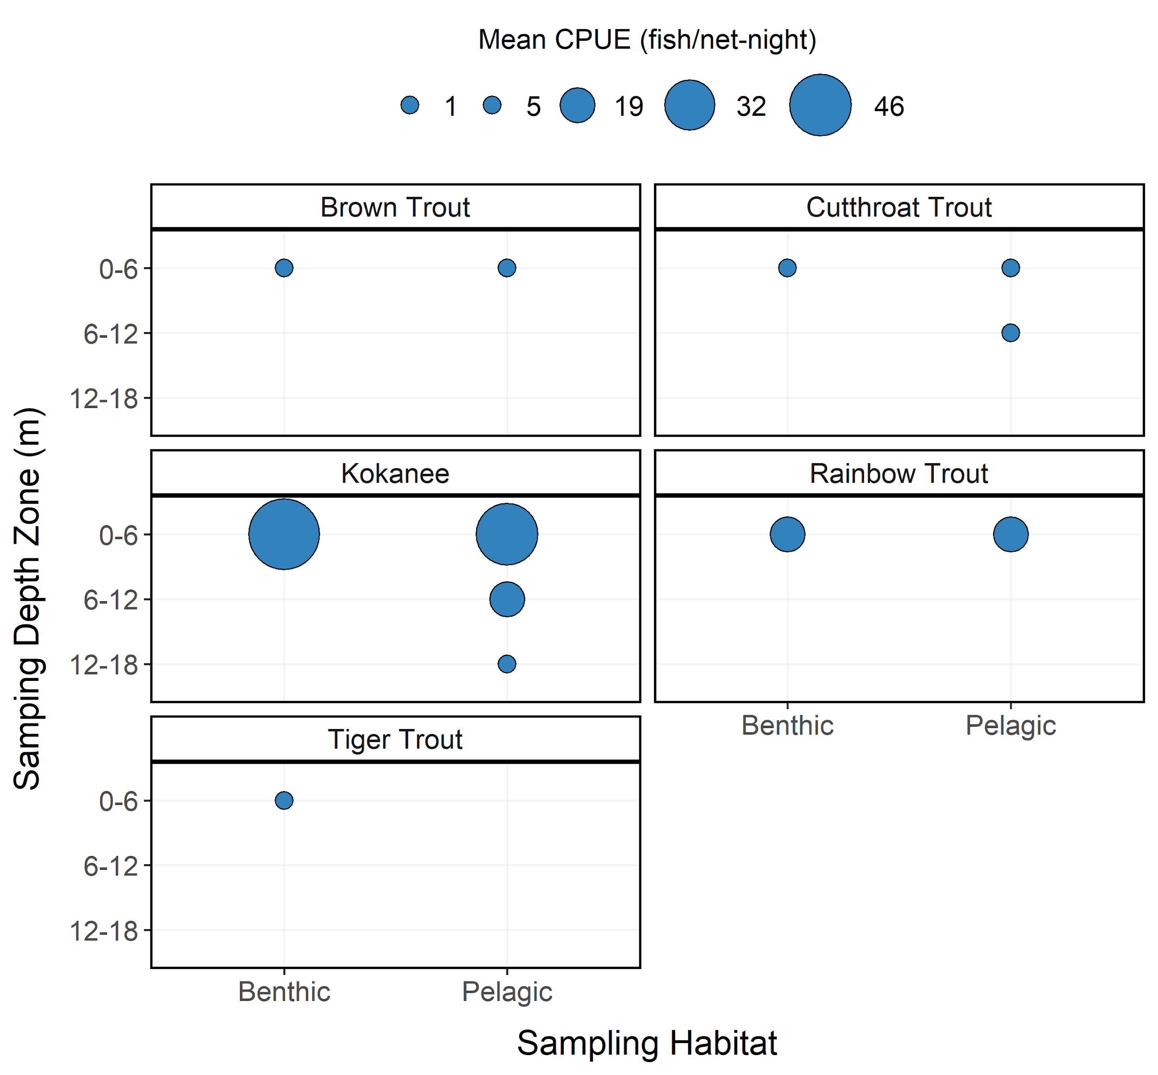

Figure 4: Mean relative abundance (CPUE; fish/net-night) of Brown Trout, Cutthroat Trout, Kokanee, Rainbow Trout, and Tiger Trout at each sampling depth and habitat zones from Causey Reservoir in 2023. CPUE is depicted with varying point size and the diameter of the point is directly proportional to CPUE. No sampling was conducted in the 6-12 and 12-18 m depth zones for benthic habitat.

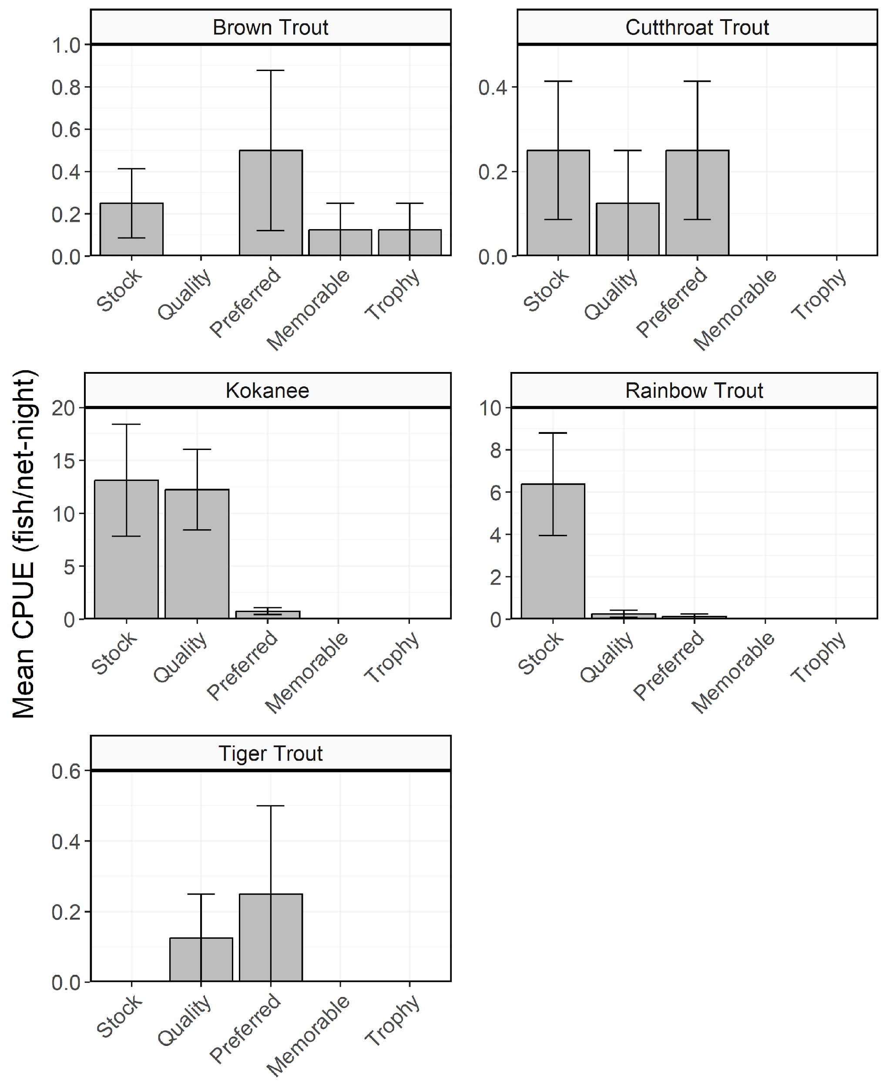

Figure 5: Mean relative abundance (CPUE; fish/net-night) of Brown Trout, Cutthroat Trout, Kokanee, Rainbow Trout, and Tiger Trout within each Gablehouse length category sampled in curtain nets from Causey Reservoir in 2023. Error bars indicate standard error.

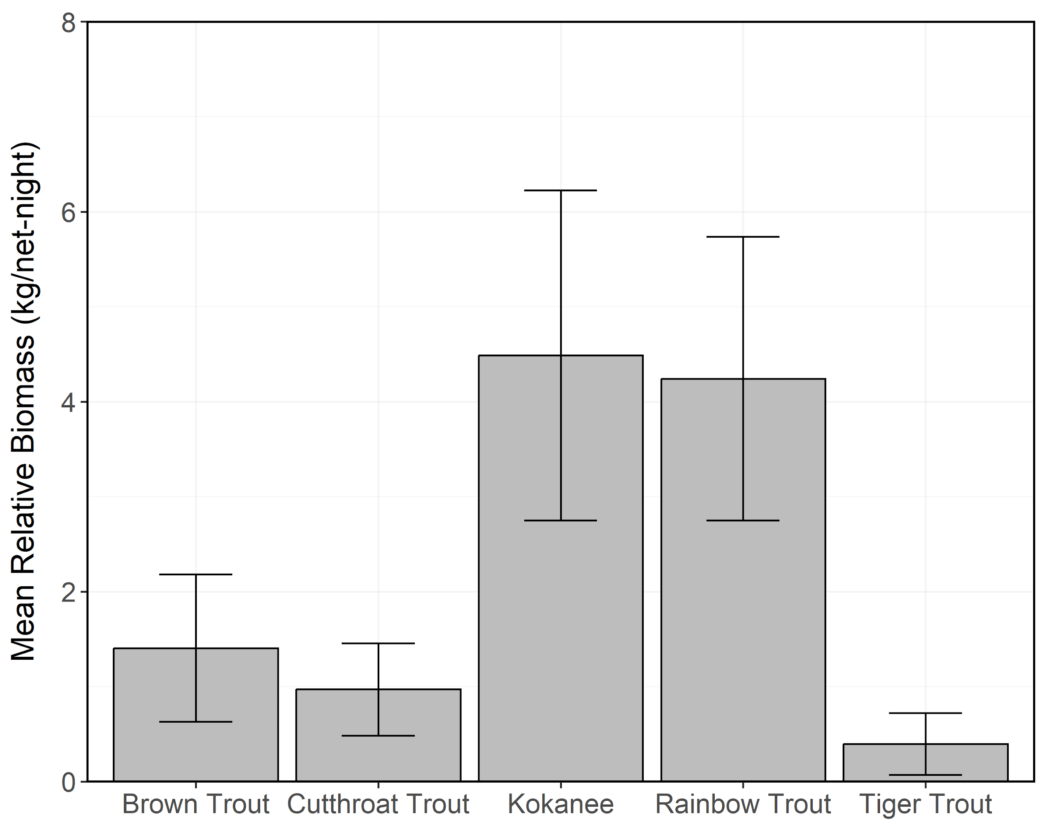

Figure 6: Mean relative biomass (kg/net-night) of stock-length Brown Trout, Cutthroat Trout, Kokanee, Rainbow Trout, and Tiger Trout sampled in curtain nets from Causey Reservoir in 2004-2023. Error bars indicate standard error.

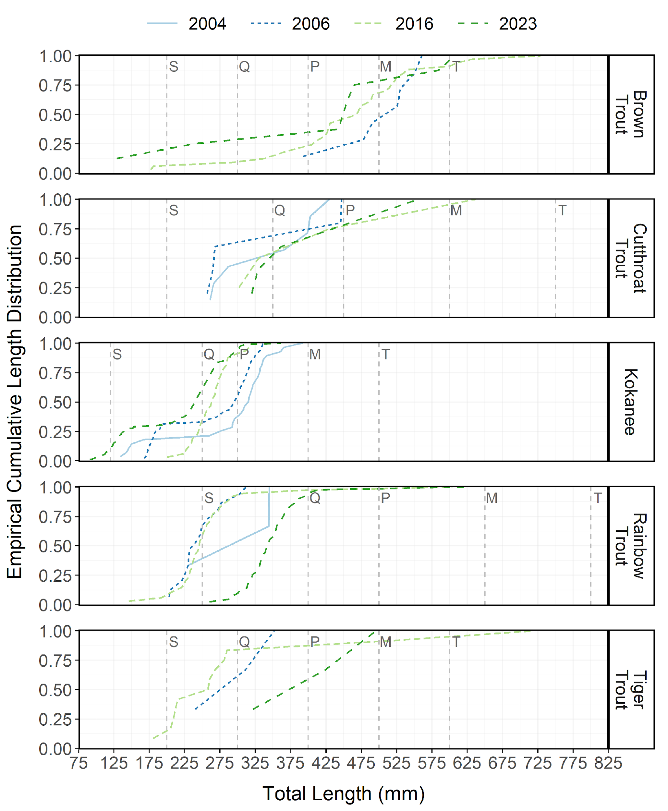

Figure 7: Empirical cumulative total length (mm) distribution of Brown Trout, Cutthroat Trout, Kokanee, Rainbow Trout, and Tiger Trout sampled during curtain net and electrofishing surveys from Causey Reservoir between 2004-2023.

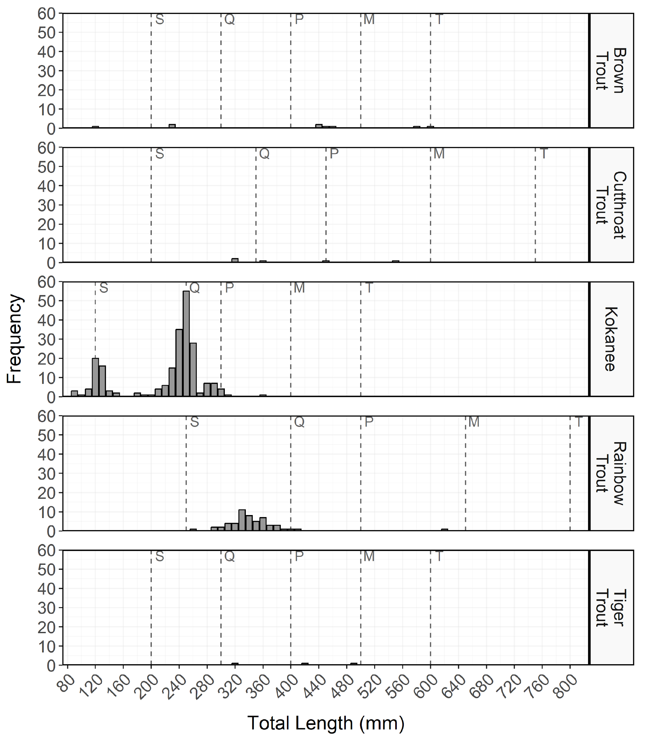

Figure 8: Total length (mm) frequency of Brown Trout, Cutthroat Trout, Kokanee, Rainbow Trout, and Tiger Trout sampled during curtain net and electrofishing surveys from Causey Reservoir in 2023. The length intervals are left-inclusive and right-exclusive, and the x-axis labels represent the start of the length interval (i.e., left side). The start of each Gablehouse length category is identified by the vertical dashed lines and the category name (i.e., stock, quality, preferred, memorable, and trophy) is indicated by the first letter of each category on the right side of the dashed line.

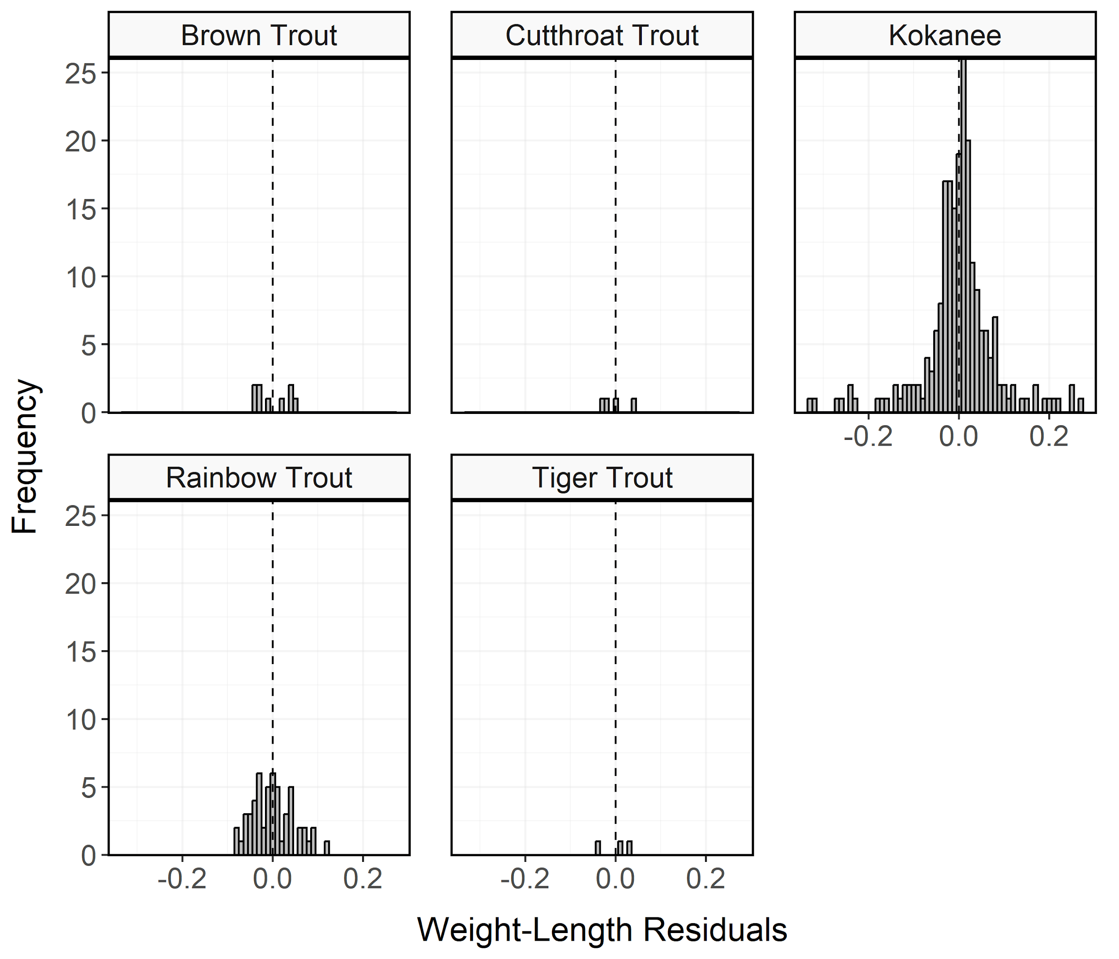

Figure 9: Histogram of residuals from the regression of log10 weight on log10 total length for Brown Trout, Cutthroat Trout, Kokanee, Rainbow Trout, and Tiger Trout sampled during curtain net and electrofishing surveys from Causey Reservoir in 2023.

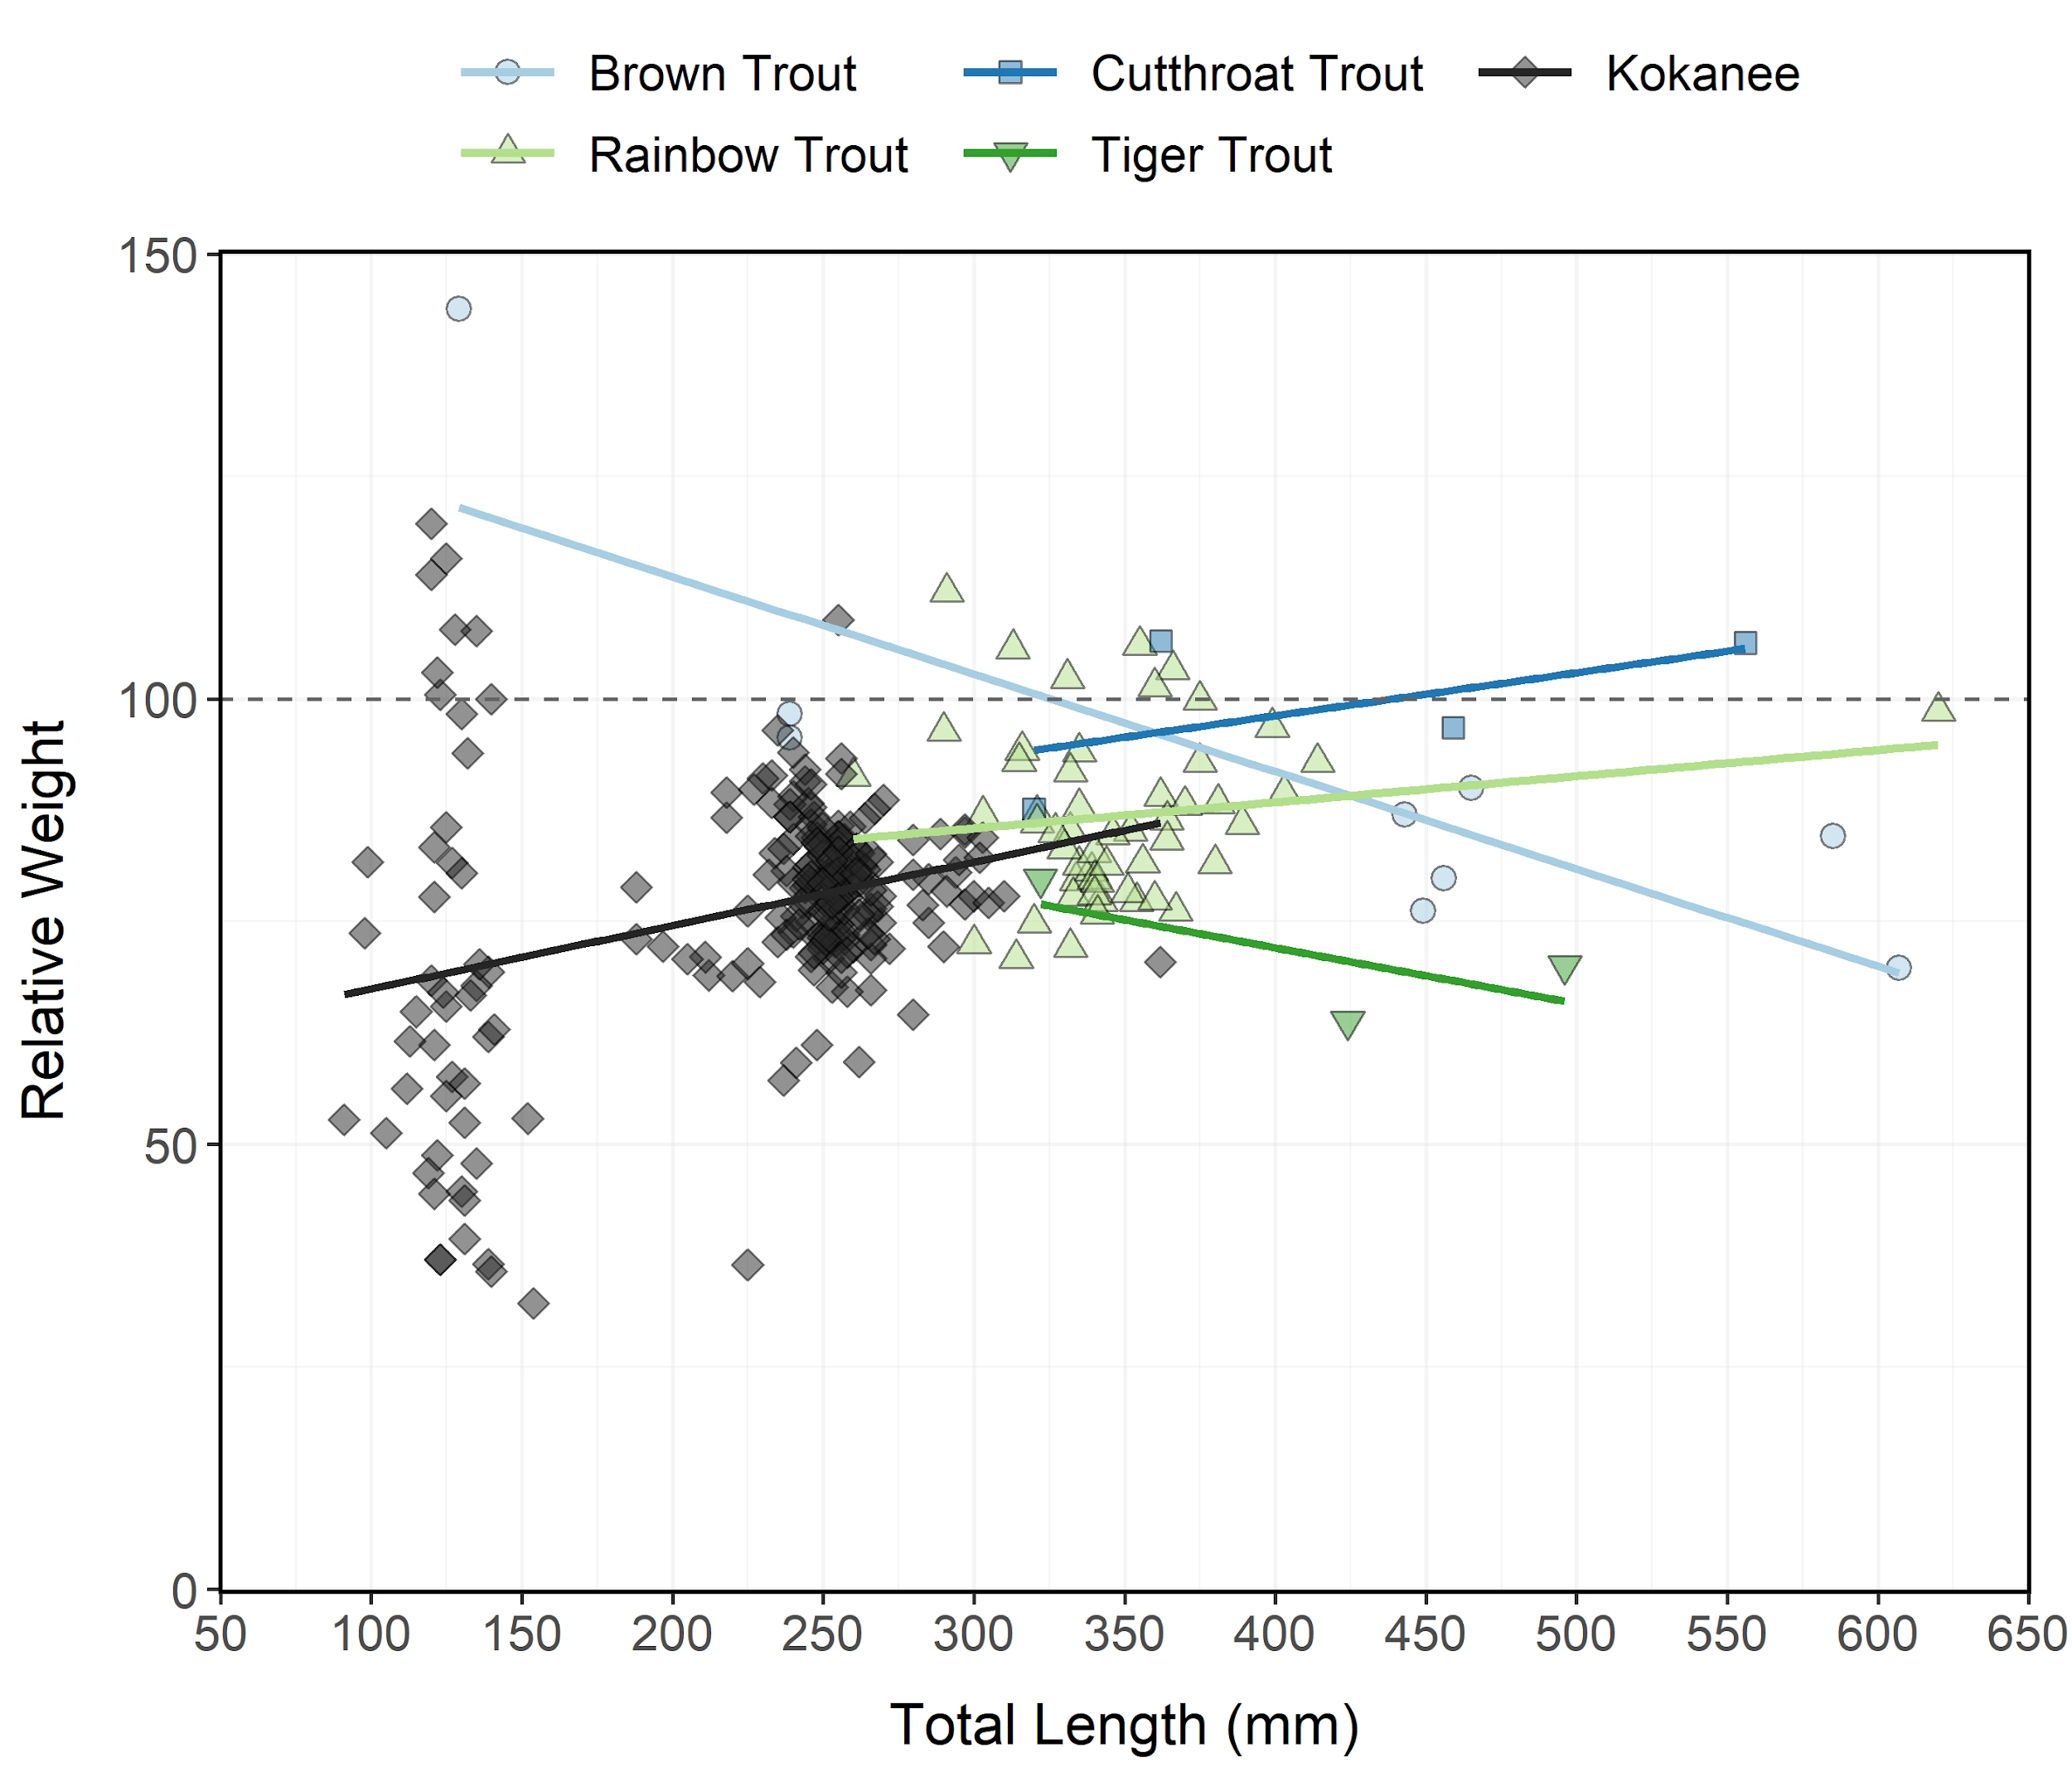

Figure 10: Relative weight (± standard error) of Brown Trout, Cutthroat Trout, Kokanee, Rainbow Trout, and Tiger Trout sampled during curtain net and electrofishing surveys from Causey Reservoir in 2023 as an index of condition. The horizontal dashed line indicates a 1:1 relationship between standard weight and relative weight.

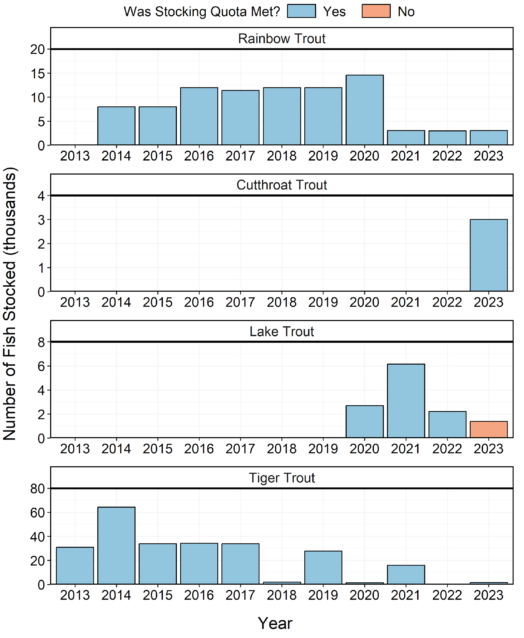

Figure 11: Number of individuals stocked in Causey Reservoir from 2013-2023. Length-at-stocking and stocking quota varies among years. A stocking quota was determined to be met if the number of stocked individuals was at least 90% of the stocking quota.